Terraform Challenge-03

Goal of the Exercise
The goal of this exercise is to test your understanding of a Cloud Compute deployment with Terraform.
You are tasked with creating a codebase for a microservice deployment on a cloud environment, using Terraform. Since our focus is not the application itself, the service will be a simple web server that returns a static page.
Requirements
Service Details
- The service will be a simple web server that returns a static page.
- You can useapache2ornginxto serve a simple HTML file.
- The service should becontainerizedand stored in aDocker registry.
- The service should be deployed on asingle VM instanceas a docker container.
- The image should be pulled from the registry specified earlier.
- The service shouldnotbe accessible from the internet but only through aLoad Balancer, except for SSH access from specific IP addresses.
Deliverables
You are to provide the following as part of your solution:
- Dockerfileto build the image.
- Terraform codebaseto deploy the following:
  - Docker registry
  - VPC and all required networking resources
  - EC2 instance
  - Load Balancer
Notes
- Since a CI/CD pipeline is not part of this exercise, we will work around that with the help of Terraform.
- To push the image to the Docker registry,build the image locallybefore running the Terraform code.
- Once the image registry is created, use Terraform topush the local imageto the registry.
- Similarly, use Terraform topull the imagefrom the registry and run it on the VM instance once it is created.
- For SSH access:
  - Use a locally created key.
  - Add it to the cloud provider key storage.
  - Attach it to the instance.
- UseTerraform best practicesfor file structure and code organization.
  - Use variables, locals, modules, etc. when appropriate.
- Include alltfvars, scripts, and other helper files used to deploy the application.
- You may use any cloud provider of your choosing, althoughAWS is preferred.
- Use afree tier accountor atrial accountto deploy the resources.

Step 1 — Create the simple web application
Create a folder named terraform microservices and create index.html folder within this folder.
Put html code in index.html folder
<!DOCTYPE html>
<html>
<head>
<title>Terraform Microservice</title>
</head>
<body>
<h1>Hello from Terraform Docker Microservice!</h1>
<p>Application deployed using AWS, Terraform, Docker and ECR.</p>
</body>
</html>
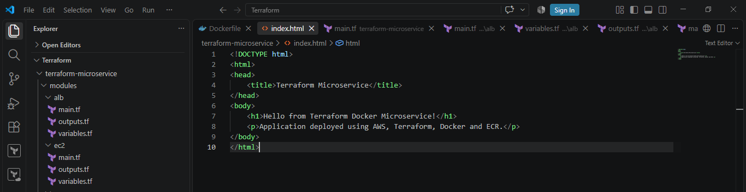
Step 2 — Create Dockerfile
Create another folder within terraform-services folder and use apache
FROM httpd:2.4

COPY index.html /usr/local/apache2/htdocs/index.html
EXPOSE 80
This does three things:

1. Gets Apache image
FROM httpd:2.4

2. Copies your HTML page
COPY index.html /usr/local/apache2/htdocs/index.html

3. Documents the container port
EXPOSE 80
So inside the container:
Apache
|
↓
Port 80

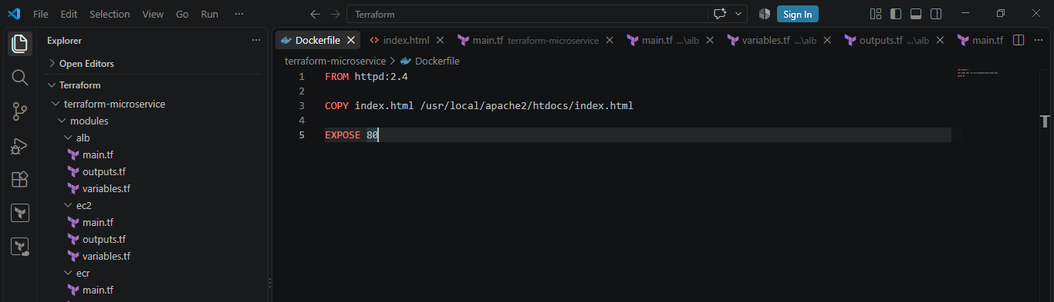

Step 3 — Build the Docker image locally
Build the image locally before running Terraform.
Go into the app directory:
cd terraform-services
Build:
docker build -t terraform-microservice:v1 .

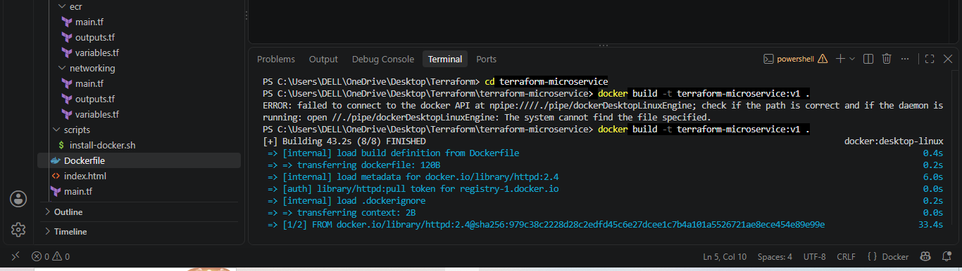

Check:
docker images
You should see:
terraform-microservice
v1

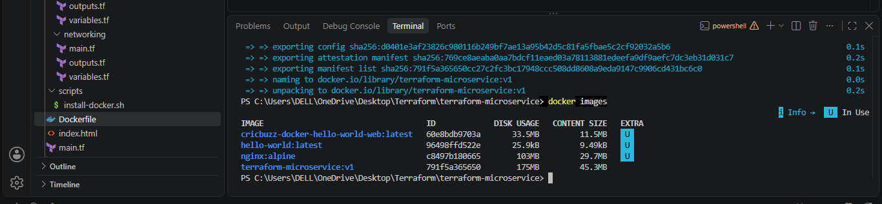

Step 4 — Test the Docker image locally
Run:
docker run -d -p 8080:80 --name terraform-test terraform-microservice:v1

Now open:
http://localhost:8080
You should see:
Hello from Terraform Docker Microservice!

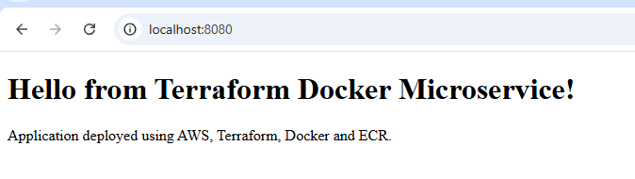
Check:
docker ps
Then stop/remove the test:
docker rm -f terraform-test
At this point:
Docker image
terraform-microservice:v1
exists on your local machine.

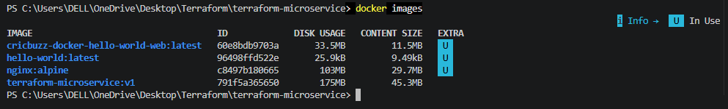

Step 5 — Create AWS key pair
Use a locally created key.
You can create an SSH key locally.
For example, using PowerShell:
ssh-keygen -t rsa -b 4096
You can accept the default location or specify something like:
C:\Users\DELL\.ssh\terraform-key
This creates:
terraform-key
terraform-key.pub

Important
Never upload the private key:
terraform-key
to GitHub.
Terraform will upload the public key:
terraform-key.pub
to AWS.

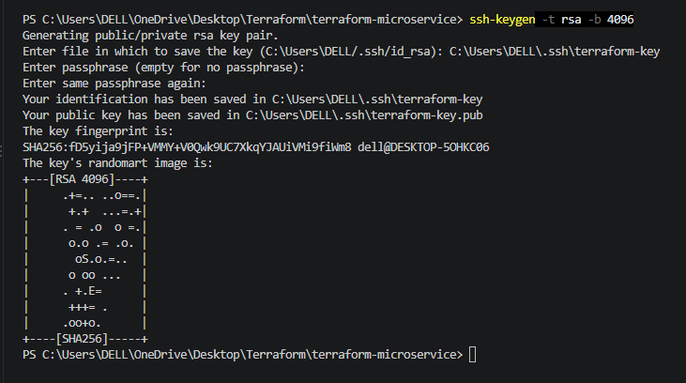

Step 6:Create User_data.sh
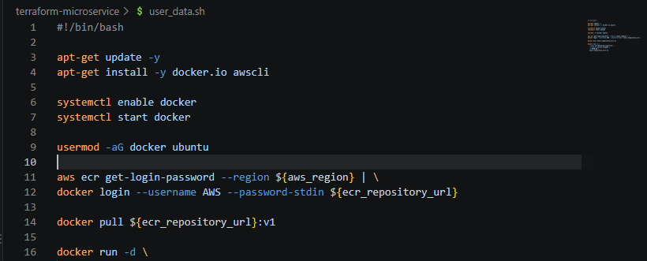

Step 7 — Create Terraform variables
Create:
variables.tf
For example:
variable "aws_region" {
description = "AWS region"
type = string
default = "eu-north-1"
}

variable "ssh_allowed_cidr" {
description = "IP address allowed to SSH"
type = string
}

variable "key_name" {
description = "AWS EC2 key pair name"
type = string
default = "terraform-key"
}

variable "public_key_path" {
description = "Path to SSH public key"
type = string
}

variable "docker_image" {
description = "Local Docker image"
type = string
default = "terraform-microservice:v1"
}

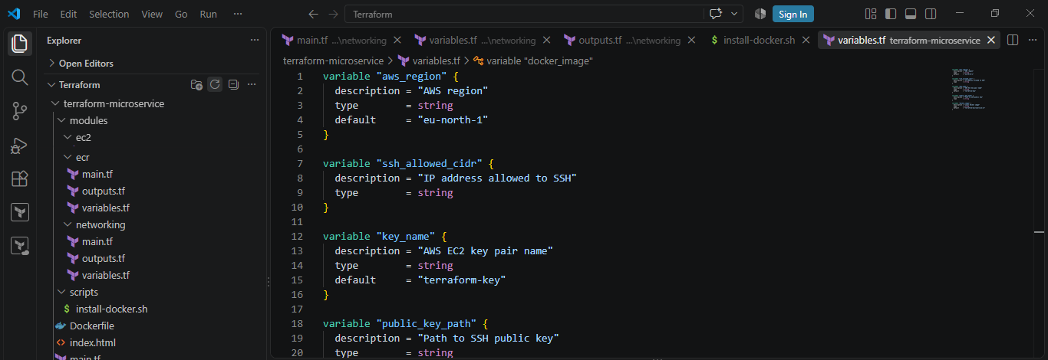

Step 8— Create terraform.tfvars
Create:
terraform.tfvars
Example:
aws_region = "eu-north-1"
ssh_allowed_cidr = "YOUR_PUBLIC_IP/32"
key_name = "terraform-key"
public_key_path = "C:/Users/DELL/.ssh/terraform-key.pub"
docker_image = "terraform-microservice:v1"

Why /32?
If your IP is:
203.0.113.25
then:
203.0.113.25/32
means:
Allow only this specific IP address.
Don't use:
0.0.0.0/0
for SSH in this assignment because the requirement specifically says SSH from specific IP addresses.
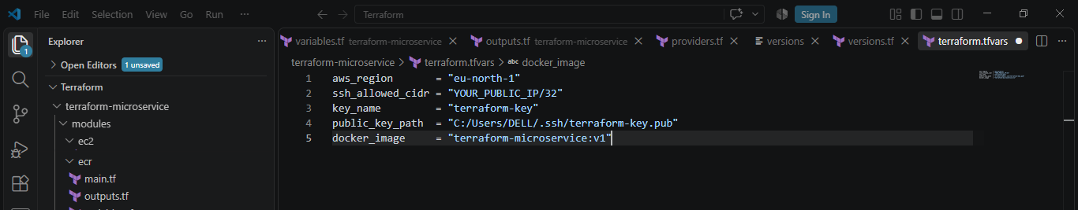

Step 9— Configure Terraform
Create:
versions.tf
terraform {
required_providers {
aws = {
source = "hashicorp/aws"
version = "~> 6.0"
}

docker = {
source = "kreuzwerker/docker"
}
}
}

provider "aws" {
region = var.aws_region
}

provider "docker" {
}
Here we're using two providers:
AWS Provider
↓
Creates AWS infrastructure

Docker Provider
↓
Works with Docker images/containers

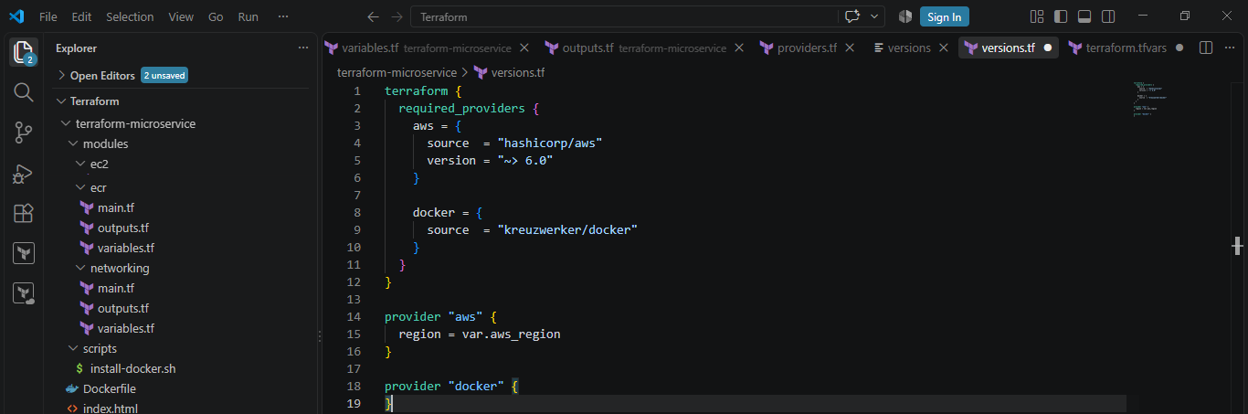

Step 10 — Create ECR repository
In main.tf:
resource "aws_ecr_repository" "app" {
name = "terraform-microservice"

image_scanning_configuration {
scan_on_push = true
}

tags = {
Name = "terraform-microservice"
}
}
ECR = Elastic Container Registry.
It stores your Docker image.
Think:
Local Docker
|
| push
↓
AWS ECR
|
| pull
↓
EC2
|
↓
Docker Container

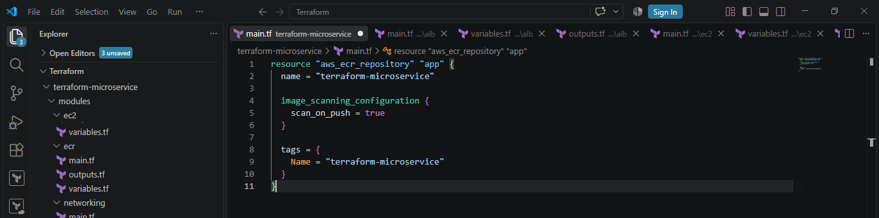

Step 11 — Create VPC
Create:
resource "aws_vpc" "main" {
cidr_block = "10.0.0.0/16"

tags = {
Name = "microservice-vpc"
}
}
Your network:
VPC
10.0.0.0/16

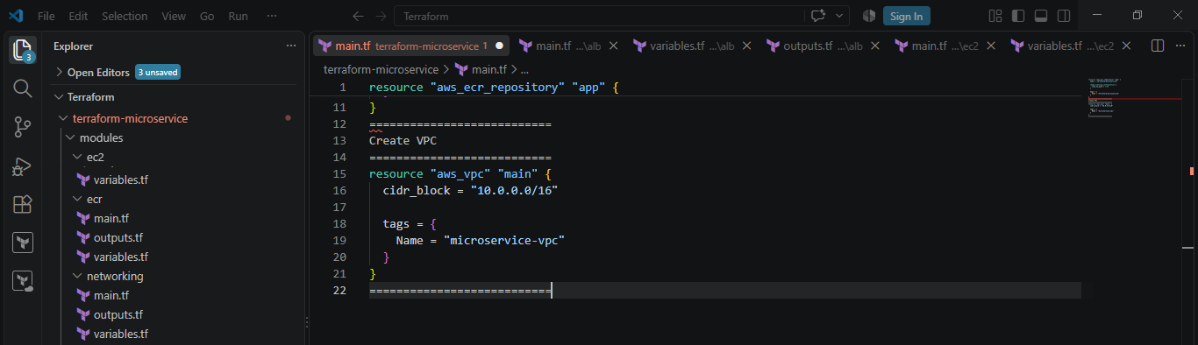

Step 12 — Create two public subnets
An Application Load Balancer should normally use subnets in at least two Availability Zones.
Create:
resource "aws_subnet" "public_1" {
vpc_id = aws_vpc.main.id
cidr_block = "10.0.1.0/24"
availability_zone = "eu-north-1a"
map_public_ip_on_launch = true

tags = {
Name = "public-subnet-1"
}
}

resource "aws_subnet" "public_2" {
vpc_id = aws_vpc.main.id
cidr_block = "10.0.2.0/24"
availability_zone = "eu-north-1b"
map_public_ip_on_launch = true

tags = {
Name = "public-subnet-2"
}
}
Architecture:
VPC
10.0.0.0/16
|
+--------------------+
| |
↓ ↓
Subnet 1 Subnet 2
10.0.1.0/24 10.0.2.0/24
eu-north-1a eu-north-1b

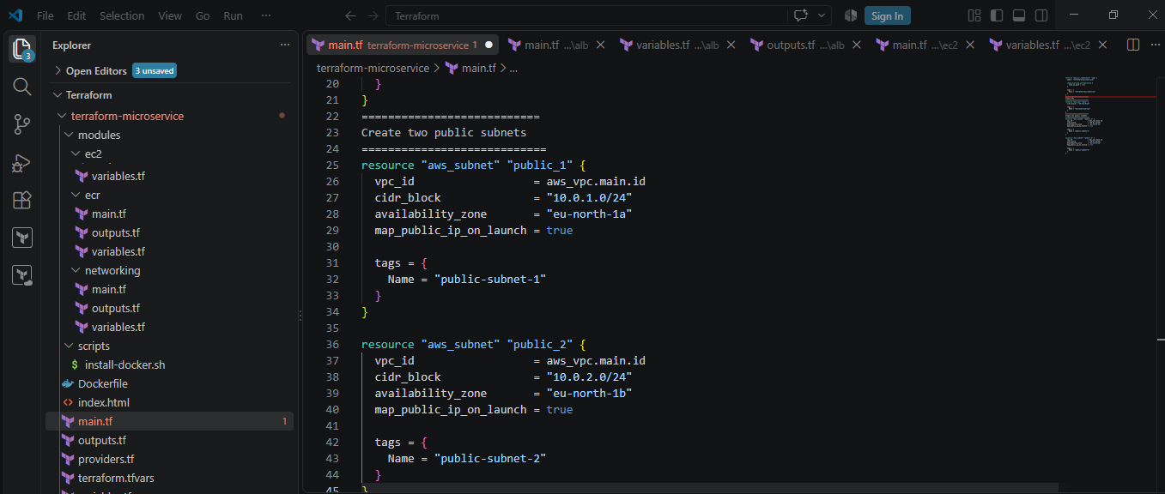

Step 13 — Internet Gateway
resource "aws_internet_gateway" "main" {
vpc_id = aws_vpc.main.id

tags = {
Name = "microservice-igw"
}
}
This provides internet connectivity for the public subnets.
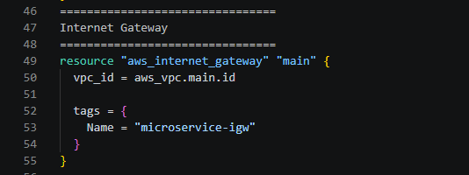

Step 14 — Route table
resource "aws_route_table" "public" {
vpc_id = aws_vpc.main.id

route {
cidr_block = "0.0.0.0/0"
gateway_id = aws_internet_gateway.main.id
}

tags = {
Name = "public-route-table"
}
}
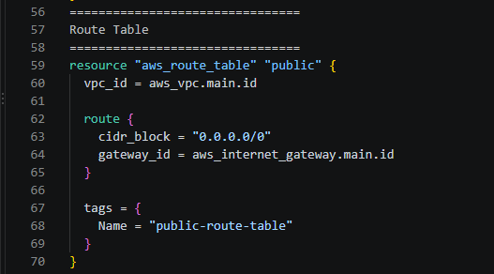
Then associate both subnets:
resource "aws_route_table_association" "public_1" {
subnet_id = aws_subnet.public_1.id
route_table_id = aws_route_table.public.id
}

resource "aws_route_table_association" "public_2" {
subnet_id = aws_subnet.public_2.id
route_table_id = aws_route_table.public.id
}

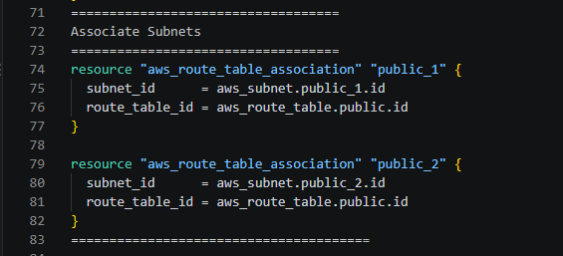

Step 15— Create ALB Security Group
The ALB needs to accept HTTP from the internet.
resource "aws_security_group" "alb" {
name = "alb-security-group"
description = "Allow HTTP to ALB"
vpc_id = aws_vpc.main.id

ingress {
description = "HTTP"
from_port = 80
to_port = 80
protocol = "tcp"
cidr_blocks = ["0.0.0.0/0"]
}

egress {
from_port = 0
to_port = 0
protocol = "-1"
cidr_blocks = ["0.0.0.0/0"]
}

tags = {
Name = "alb-security-group"
}
}
Traffic:
Internet
|
| HTTP :80
↓
ALB Security Group

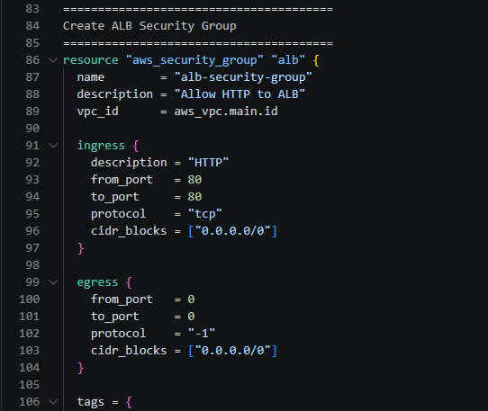

Step 16 — Create EC2 Security Group
This is where you enforce the important requirement.
The EC2 should allow:
SSH → only YOUR IP
8080 → only ALB

Internet cannot do:
Internet → EC2:8080 ❌

ALB can do:
ALB → EC2:8080 ✅

Your IP can do:
Your IP → EC2:22 ✅

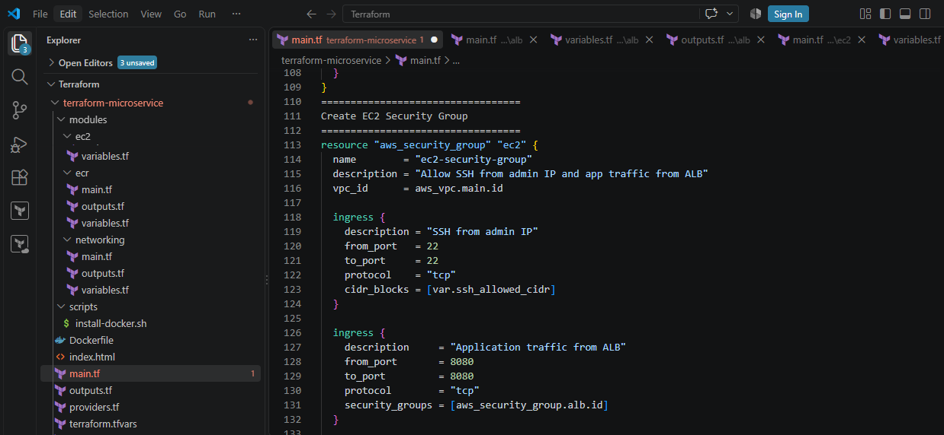

Step 17 — Create IAM role for EC2

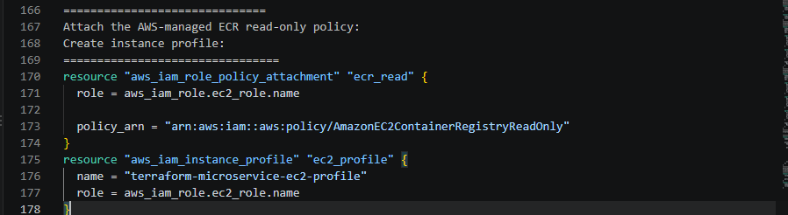

Step 18 — Create AWS key pair using your local key
Terraform can upload your public key to AWS:

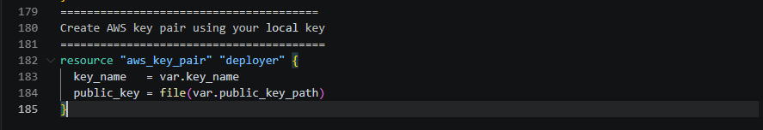

Step 19 — Create EC2
For a free-tier-conscious lab, you can use a small instance such as:
instance_type = "t3.micro"
You'll need an appropriate Ubuntu AMI or Amazon Linux AMI for eu-north-1.
The EC2 should have a public IP in this simpler lab design so you can SSH directly, but port 8080 is not open to the internet.
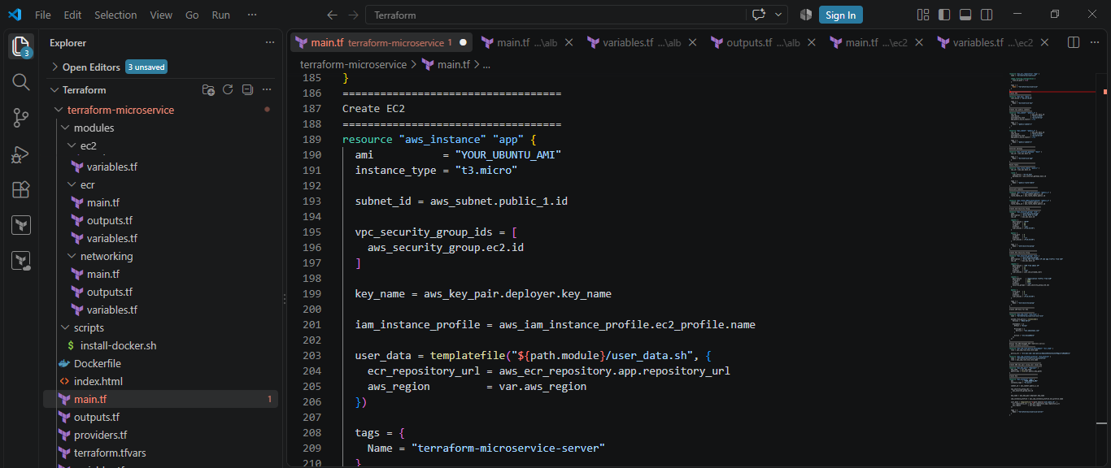

Step 20 — Create the Target Group
The ALB needs to know where to send traffic.
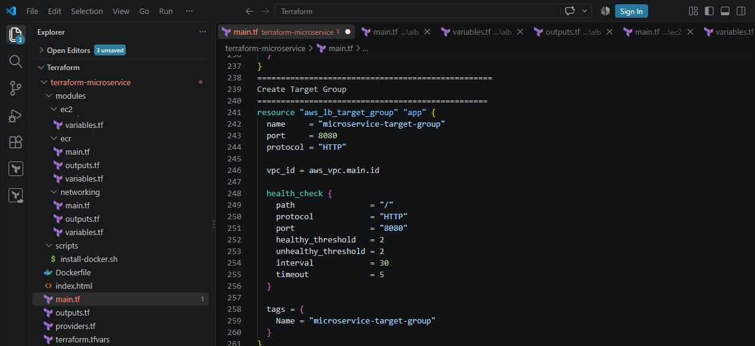

Step 21 — Register EC2 with Target Group

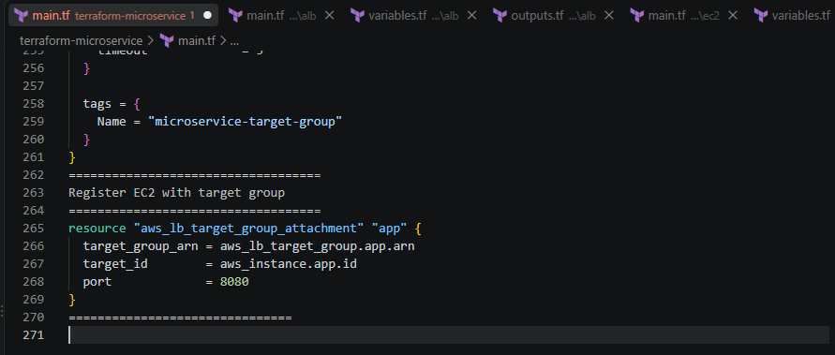
Step 22 — Create Application Load Balancer
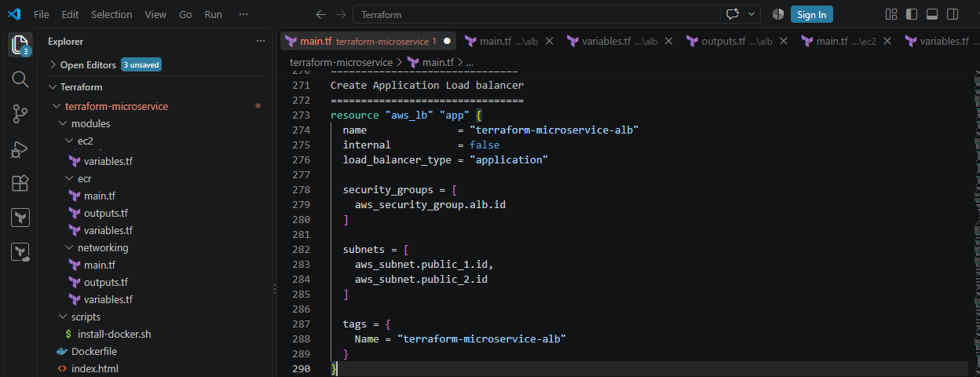
Step 23 — Create ALB Listener
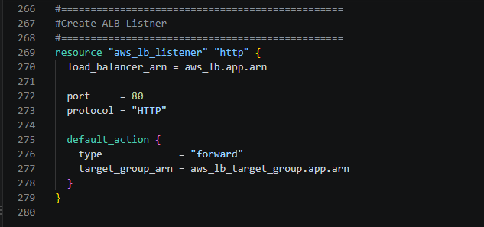

Step 24: Now run terraform init, terraform validate and terraform apply commands
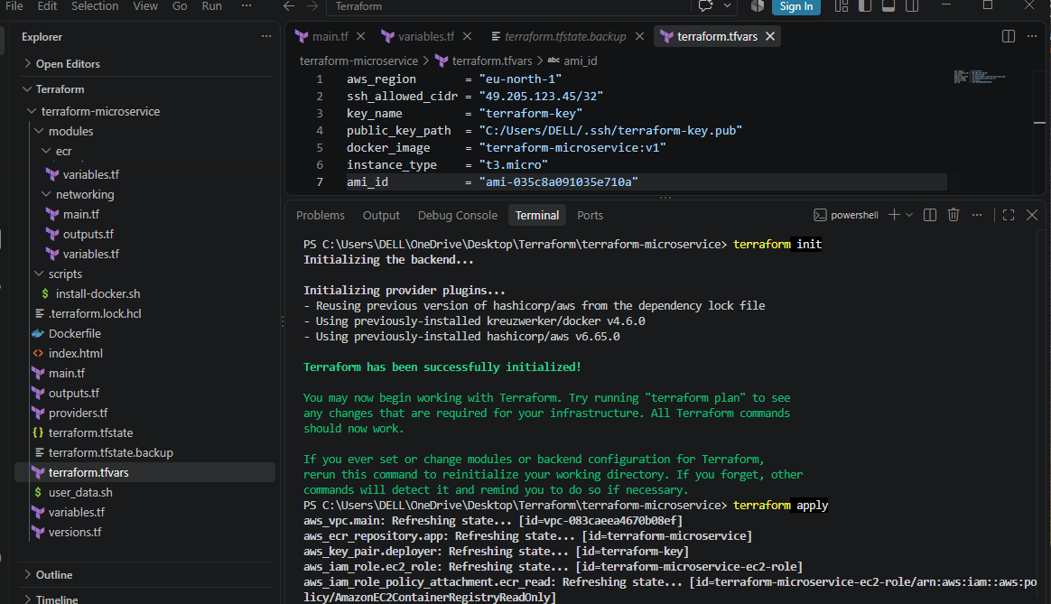
Step 25: An instance named terraform-microservice is created
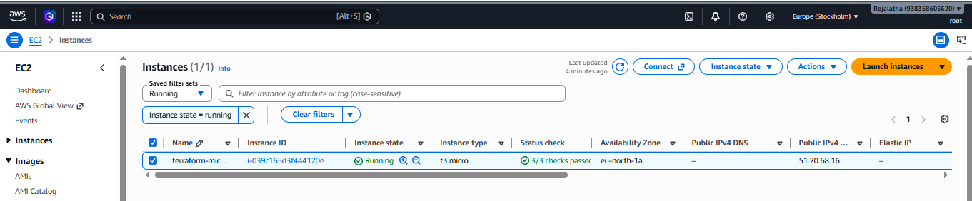
Step 26: Checked terraform output
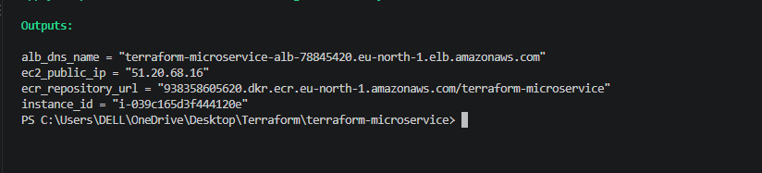
Note Alb dns name from here.
Step 27: Check EC2 instance in AWS
Check:
- Instance state → Running ✅
- Status checks → 2/2 checks passed ✅
- Security group → your EC2 security group
- Public IPv4 address → should exist if your instance is in the public subnet

Step 28: SSH into the EC2 instance
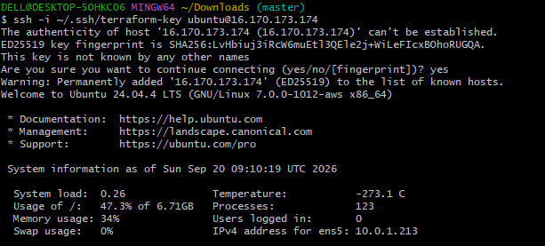
Step 29: Check Docker
Check docker version and docker status on Ec2 instance in AWS
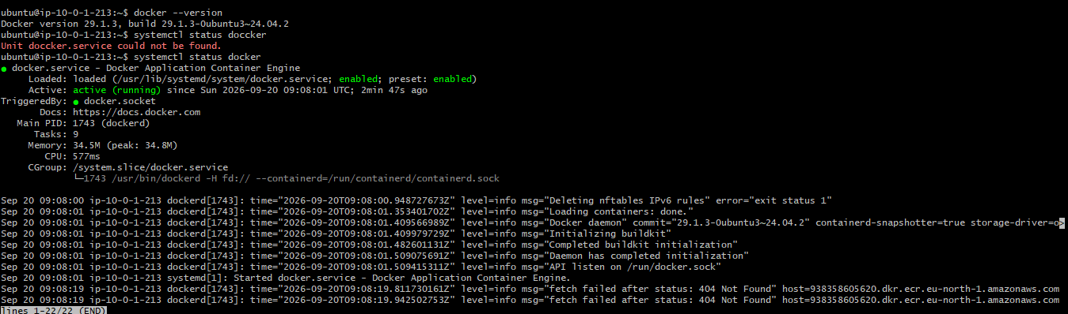

Step 30— Build the docker image manually from visual studio
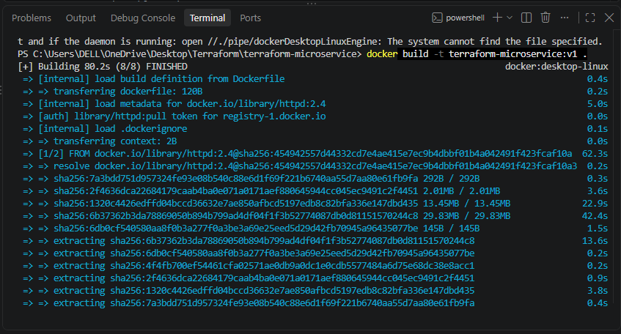

Step 31: Verify docker images
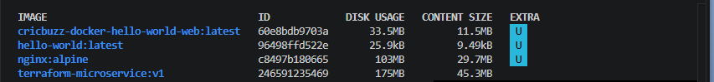
Step 32: Login to AWS ECR

Step 33 — Tag the image

Step 34 — Push the image to ECR

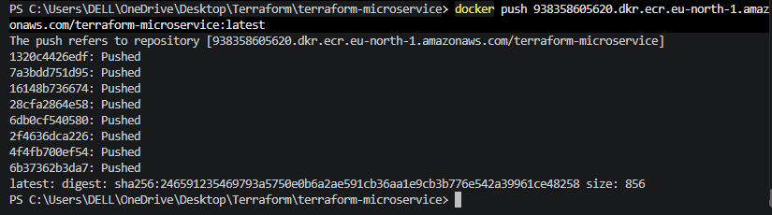

Step 35 — Verify the image is in ECR

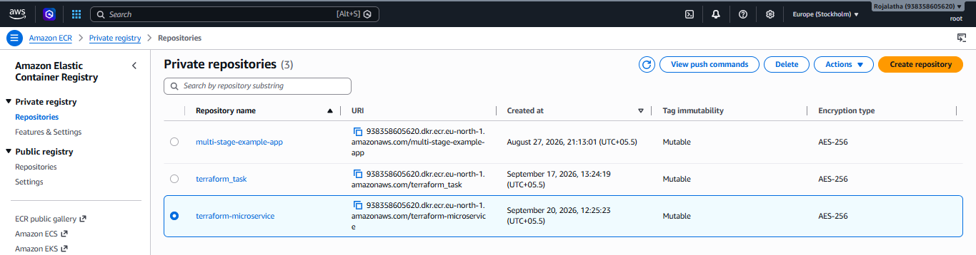

Step 36 — Recreate your EC2
Now go back to your Terraform directory and run:
terraform apply '-replace=aws_instance.app'
Type:
yes
This is important because your previous EC2 tried to pull the image before it existed in ECR.
The new EC2 will run your user_data.sh automatically.
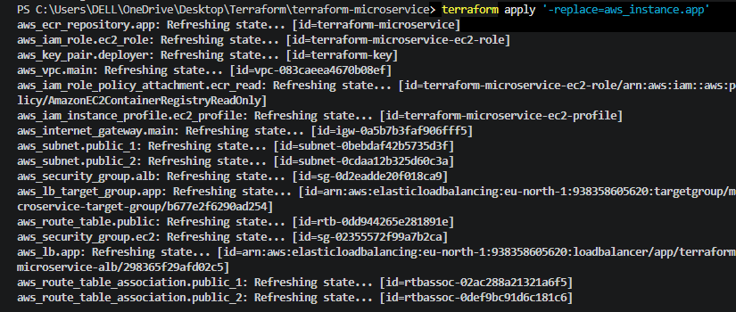
Now ssh into new EC2 instance and verify the docker images:

Step 37 — Test the application from EC2
Inside EC2:
curl http://localhost:8080
You should receive your HTML page, something like:
<h1>Hello from Terraform Microservice!</h1>
This is an important test because it confirms:
EC2 → Docker → Nginx → HTML
is working.
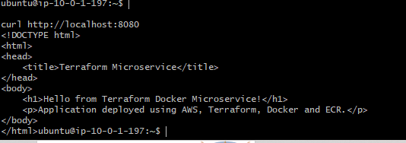

Step 38 — Check the ALB target
Go to:
AWS Console → EC2 → Target Groups
Find your target group, probably:
terraform-microservice-tg
Open it → Targets.
Your EC2 should show:
Health status: Healthy

If it says Unhealthy

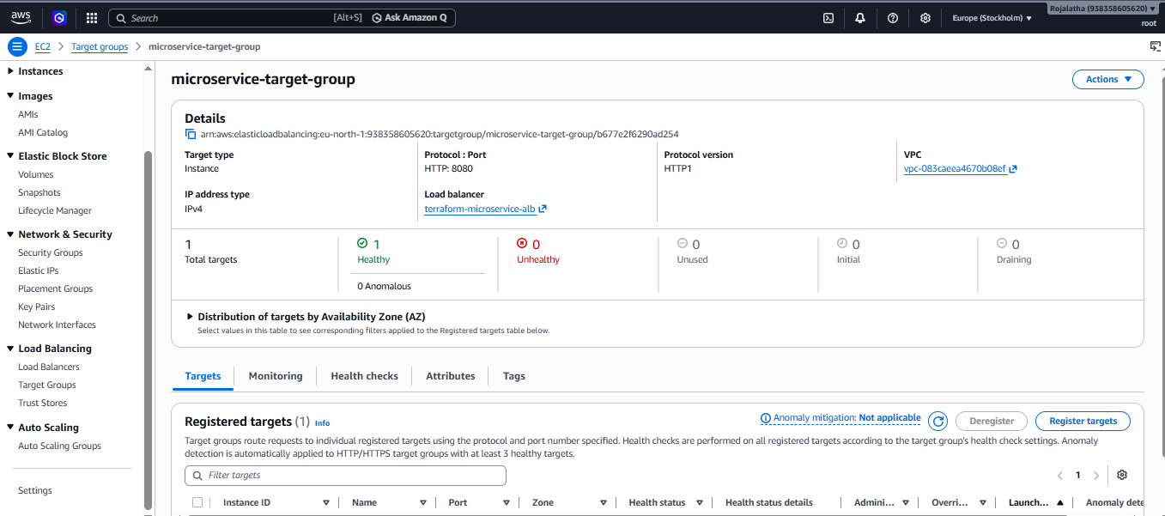

Step 39 — Test the ALB from your Windows browser
Take the ALB DNS name from:
terraform output
Then open:
http://YOUR-ALB-DNS-NAME
For example:
http://terraform-microservice-alb-123456.eu-north-1.elb.amazonaws.com
You should see your static webpage.

